ASD Useful Resources
Websites
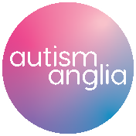
https://www.autism.org.uk/ https://www.autism-anglia.org.uk/

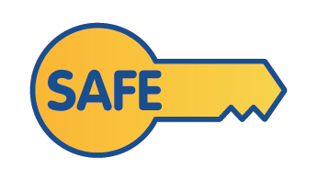
https://safeessex.org.uk/ https://pop-essex.org/

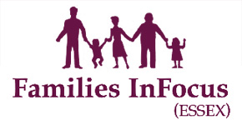
http://www.familiesinfocusessex.org.uk/ www.snapcharity.org

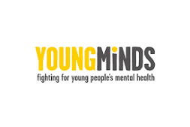
www.themazegroup.co.uk www.youngminds.org.uk

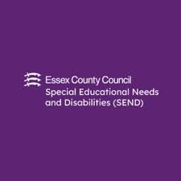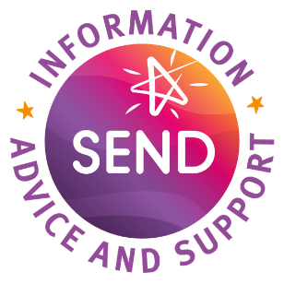
https://send.essex.gov.uk/ https://www.essexsendiass.co.uk/
Good Beginnings programme: https://send.essex.gov.uk/search-support-groups-and-activities/good-beginnings-course
Books and websites for parents
Amazing Things Happen: Amazing Things Happen - by Alexander Amelines - YouTube
The Autistic Spectrum; a guide for parents and professionals. – Lorna Wing
How to live with Autism and Asperger Syndrome; Practical strategies for parents and professionals. - Chris Williams and Barry Wright
Telling your child about their diagnosis - https://www.autism.org.uk/advice-and-guidance/topics/diagnosis/disclosing-your-autism/parents-and-carers
Talking to your child about their Autism – www.nhs.uk/livewell/autism Explaining to your child that they have autism can be difficult for some parents. This website offers advice on how to have the conversation.
After your child’s diagnosis – www.autism.org.uk/about/diagnosis/children/recently-diagnosed Gives information, advice and support for the child, siblings and parents.
“Supporting your Neurodiverse Child” Family Resource Pack for Essex, produced by the Essex Family Forum http://www.essexlocaloffer.org.uk/wp-content/uploads/2021/11/ECC-Supporting-Your-Neurodiverse-Child-V5-Accessible-Low-Res.pdf

‘Understanding Autism’ course designed by the University of Kent. To access this visit www.futurelearn.com and search for the module ‘Understanding Autism’ where you can then register for the course for free.

Books to read with children
The Social skills picture book. – Jeb Baker (age 8+)
A book about what autism can be like. – Sue Adams (age 5+)
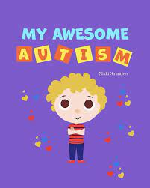
There’s a Volcano in my Tummy. - Warwick Pudney and Elaine Whitehouse (age 6 +)
My awesome autism. – Nikki Saunders

The Spectrum Girl’s Survival Guide. – Siena Castellon

He’s Not Naughty. Deborah Brownson

This is me! I am who I’m meant to be! Amy Pflueger

The superhero brain. Christel Land

Social Skills Resources
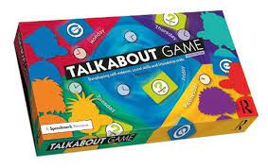
Social Behaviour and Personal Safety Illustrated Colour cards – Speechmark
Mad Sad Glad Game – winslow press
Talkabout Activity Books & Talkabout Board Game– Speechmark

